STATA analysis and discussions

Name of student

Name of professor

University

Course

**Introduction**

This is analysis based on the patient STATA variables. The variables are taken based on the way the patient is responding to the various methods of treatment on the HIV virus, the variables are changed quite a number of times to monitor the difference in patient reaction. A few variables here and there may be changed but the objectives of the file task and assignment are still the same.

The variables were changed overtime and constantly monitored to check the way the patient was likely to behave in regards to the treatment cycle. Some of these variables include prep, concern, stigma and worry.

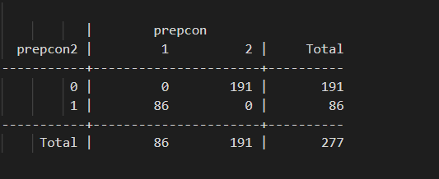

The logistic regression model in this context would measure the probability of a patient recovering or succumbing to depression based on stigma or the probability of the patient living longer due to proper treatment and medication of the disease.

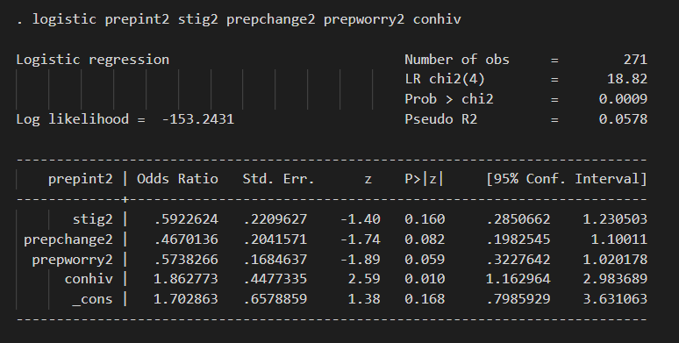

Interpreting the sample logistic regression obtained.

The odds ratio measures the probability of arriving at the pre-empted variable, e.g. stigma, given the pre-change and the prep worry. The probability chi2 is 0.0009 which is of less significance to the whole population.

The variables that are statistically significant include the prep, stigma, conhiv, osptherapy, because their relationships will be used to measure the outcome of the patient status that is alive, unwell or dead. Further, these variables can be used to predict the behavior of the patient in the near future.

Since co- linearity measure those variables that are closely related to each other, this means that wen measuring or trying to understand patient data, we can only take those variables within the same Cartesian. For instance, we cannot take patient height and compare with patient pre medication, while we can take medication and compare with stigma. This is the way co-linearity would work.